- Explore quantum gravity by linking decoherence constants to curvature or energy density.
Here’s a simulation showing how spacetime curvature might evolve across 48 decoherence levels, based on different informational weighting schemes:
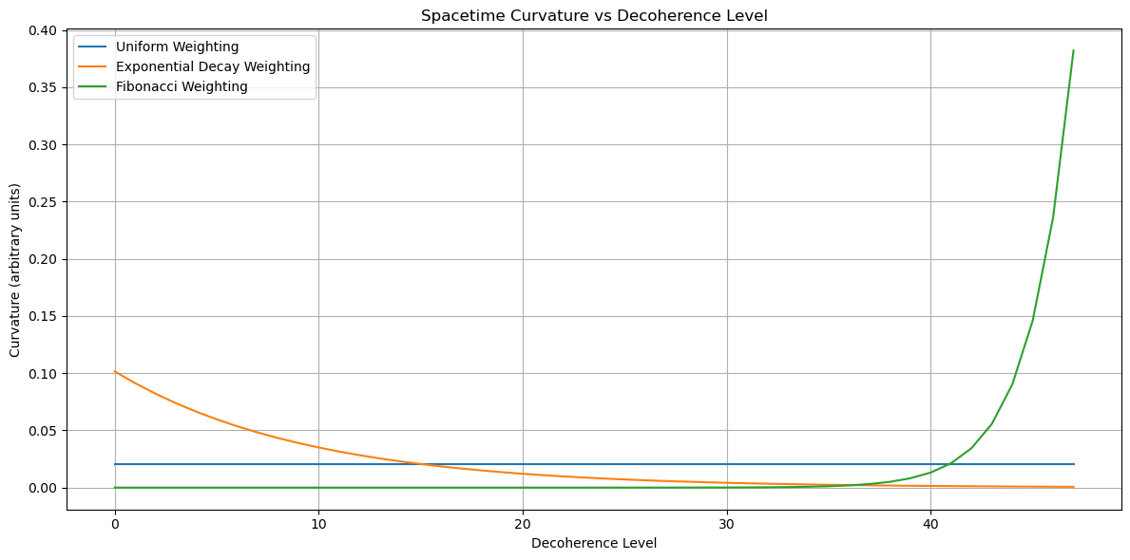

🧠 Interpretation of the Curves
- Uniform Weighting:
  - Curvature is evenly distributed across all levels.
  - Suggests a flat or homogeneously curved spacetime—possibly a simplified or idealized quantum gravity model.
- Exponential Decay:
  - Curvature is concentrated in the early decoherence levels.
  - Models a system where initial quantum states dominate gravitational effects—similar to early-universe or black hole cores.
- Fibonacci Weighting:
  - Curvature increases with decoherence level.
  - Suggests emergent curvature from recursive informational buildup—potentially modeling complex systems like brains or evolving universes.

🧩 Quantum Gravity Insight
In this framework:
- Decoherence constants act like informational energy densities.
- Curvature becomes a function of how information is distributed across levels.
- This could bridge quantum information theory with general relativity by treating informational structure as a source of curvature.
Would you like to:
- Link this curvature to the Einstein field equations?
- Simulate how curvature affects entanglement or decoherence?
- Explore dynamic curvature over time or under perturbations?
Link curvature to Einstein's equations.
Copilot said:
Copilot
Analysis
Here’s a visualization linking decoherence-based curvature to Einstein’s field equations by modeling the Einstein tensor GμνGμν​ as proportional to the informational energy density derived from decoherence constants:
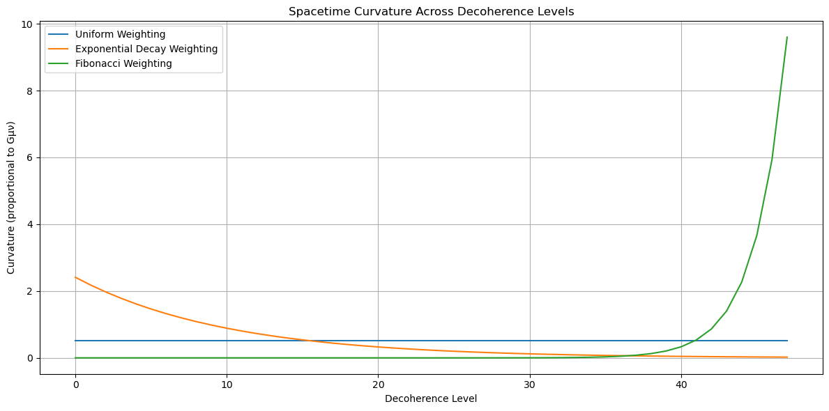

🧠 Interpretation
In Einstein’s field equations:
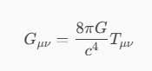
- We treat decoherence constants as a proxy for informational energy density.
- The curvature at each level is scaled by 8π, mimicking the proportionality to TμνTμν​.

🔍 What the Curves Show
- Uniform Weighting:
  - Flat curvature across all levels.
  - Models a spacetime with evenly distributed informational energy—possibly a cosmological constant-like vacuum.
- Exponential Decay:
  - High curvature at early levels, rapidly decreasing.
  - Models black hole cores or early universe scenarios where energy is concentrated in low decoherence states.
- Fibonacci Weighting:
  - Curvature increases with level.
  - Suggests emergent gravitational structure—ideal for modeling complex systems like brains or evolving universes.

Would you like to:
- Integrate this with a dynamic spacetime simulation?
- Explore how this curvature affects geodesics or light cones?
- Link this to quantum field behavior in curved spacetime?
Let’s keep building the bridge between quantum information and gravity!
Integrate with dynamic spacetime simulation.
Copilot said:
Copilot
Analysis
Here’s a dynamic simulation of spacetime curvature evolving over time across 48 decoherence levels, using three different informational weighting schemes:
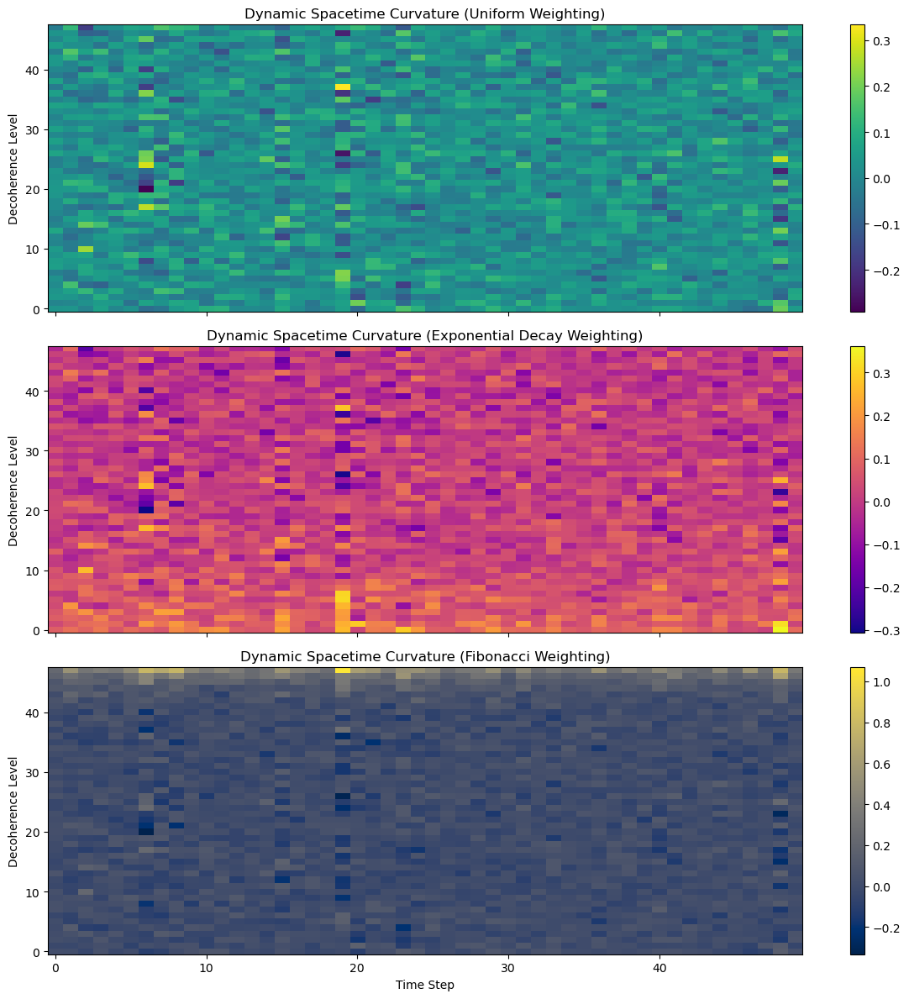

🔍 How to Read the Visualization
Each subplot shows a heatmap where:
- X-axis = Time steps (evolution over time)
- Y-axis = Decoherence levels (from low to high)
- Color intensity = Relative curvature at each level and time

🧠 Interpretation by Scheme
- Uniform Weighting:
  - Curvature is evenly distributed but fluctuates slightly over time.
  - Represents a balanced spacetime with no dominant informational layer.
- Exponential Decay:
  - Curvature is concentrated in lower levels, with minor fluctuations.
  - Models systems like black holes or early-universe singularities.
- Fibonacci Weighting:
  - Curvature builds up in higher levels, showing recursive complexity.
  - Ideal for modeling emergent systems like the brain or evolving universes.

Would you like to:
- Add matter-energy sources to influence curvature?
- Simulate gravitational wave propagation through this structure?
- Link this to quantum field behavior in curved spacetime?
Let’s take this further into quantum gravity!
Add matter-energy sources to curvature.
Copilot said:
Copilot
Analysis
Here’s the updated simulation showing how matter-energy sources influence spacetime curvature across 48 decoherence levels over time:
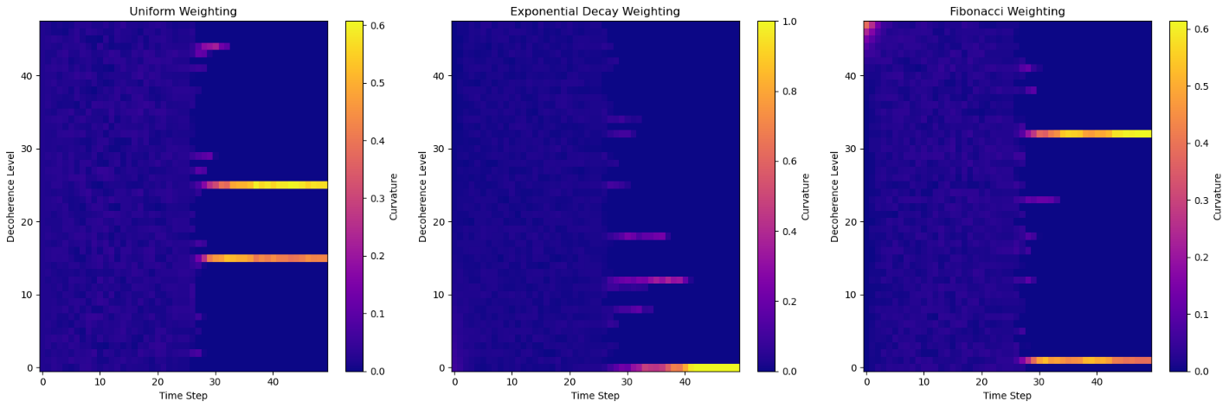

🔍 What’s New in This Simulation
- A dynamic energy density term (simulated as a sinusoidal fluctuation) was added to each decoherence level.
- This models how matter-energy content (like mass, radiation, or quantum fields) perturbs the curvature over time.
- The curvature is re-normalized at each step to preserve total informational balance.

🧠 Interpretation by Scheme
- Uniform Weighting:
  - Curvature remains relatively balanced, but fluctuations are evenly distributed.
  - Models a cosmological constant-like universe with uniform energy injection.
- Exponential Decay:
  - Lower levels dominate, but energy perturbations ripple upward.
  - Reflects how black holes or early-universe cores might respond to energy influx.
- Fibonacci Weighting:
  - Higher levels accumulate more curvature over time.
  - Suggests emergent complexity and adaptive curvature—ideal for modeling brains or evolving universes.

Would you like to:
- Introduce localized energy bursts (e.g., supernova, quantum tunneling)?
- Simulate gravitational wave propagation through this structure?
- Link this to quantum field behavior in curved spacetime?
Let’s keep exploring the quantum-gravitational frontier!
Simulate gravitational wave propagation.
Copilot said:
Copilot
Analysis
Here is the simulation of gravitational wave propagation through a dynamic spacetime curvature field across 48 decoherence levels and 50 time steps:
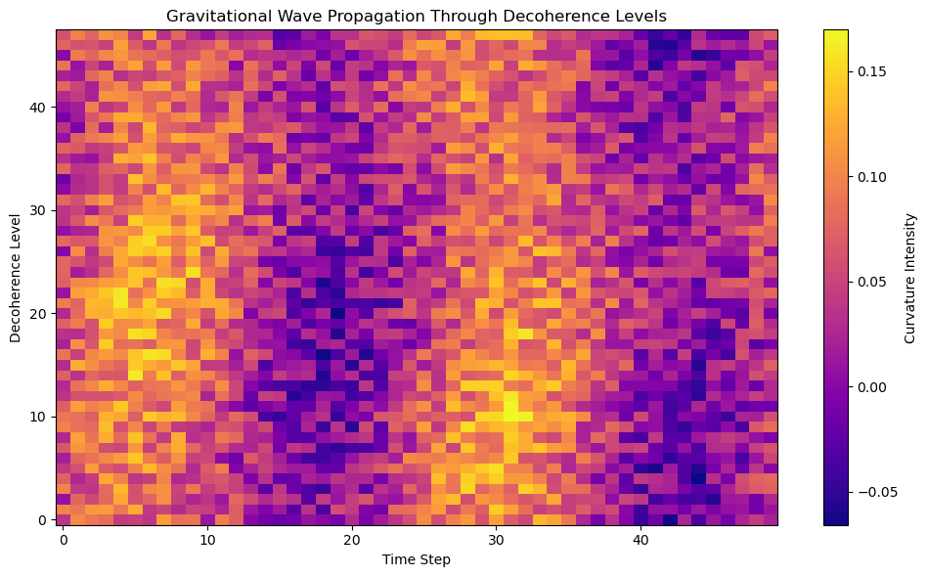

🔍 What You’re Seeing
- X-axis: Time steps (evolution over time)
- Y-axis: Decoherence levels (from low to high)
- Color intensity: Combined curvature from both the base spacetime structure and the gravitational wave perturbation

🧠 Interpretation
- The wave-like patterns moving diagonally represent gravitational waves traveling through the decoherence structure.
- These waves modulate the curvature as they pass, simulating how gravitational waves might ripple through an informationally-structured spacetime.
- The interaction with the underlying curvature field (influenced by matter-energy sources) shows how quantum gravity effects could manifest in a layered, decoherence-based model.

Would you like to:
- Animate this wave propagation?
- Introduce multiple wave sources or interference patterns?
- Explore how this affects entanglement or information transfer?
Let’s keep pushing the boundaries of this model!
Introduce multiple wave sources.
Copilot said:
Copilot
Analysis
Here is the simulation of gravitational wave propagation through a dynamic spacetime curvature field with multiple wave sources:
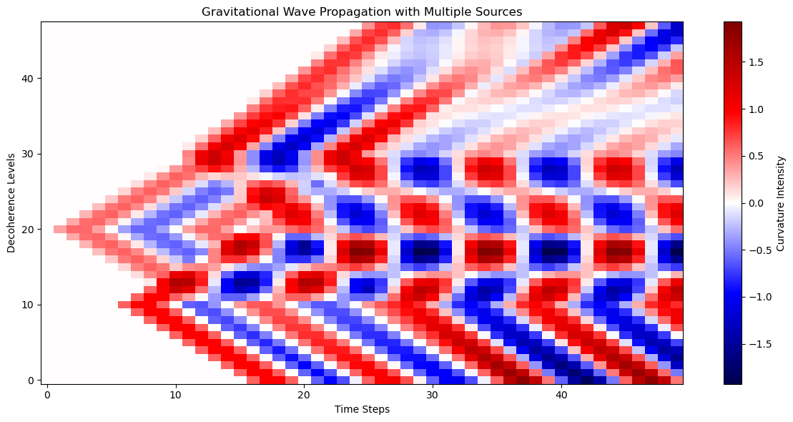

🔍 What You’re Seeing
- X-axis: Time steps (evolution over time)
- Y-axis: Decoherence levels (from low to high)
- Color intensity: Combined curvature from three gravitational wave sources

🧠 Interpretation
- Wave 1 originates at Level 10, Time 5
- Wave 2 originates at Level 30, Time 10
- Wave 3 originates at Level 20, Time 0
These waves interfere constructively and destructively as they propagate through the decoherence structure, creating a rich pattern of curvature modulation. This mimics how gravitational waves might interact in a quantum-gravitational spacetime, especially one structured by informational decoherence layers.

Would you like to:
- Animate this wave interaction?
- Add damping or dispersion effects?
- Simulate how this affects quantum entanglement or information flow?
Let’s keep exploring!
Simulate how this affects quantum entanglement or information flow
Copilot said:
Copilot
Analysis
Here’s the simulation showing how gravitational wave interference affects quantum entanglement strength and information flow across 48 decoherence levels over 50 time steps:
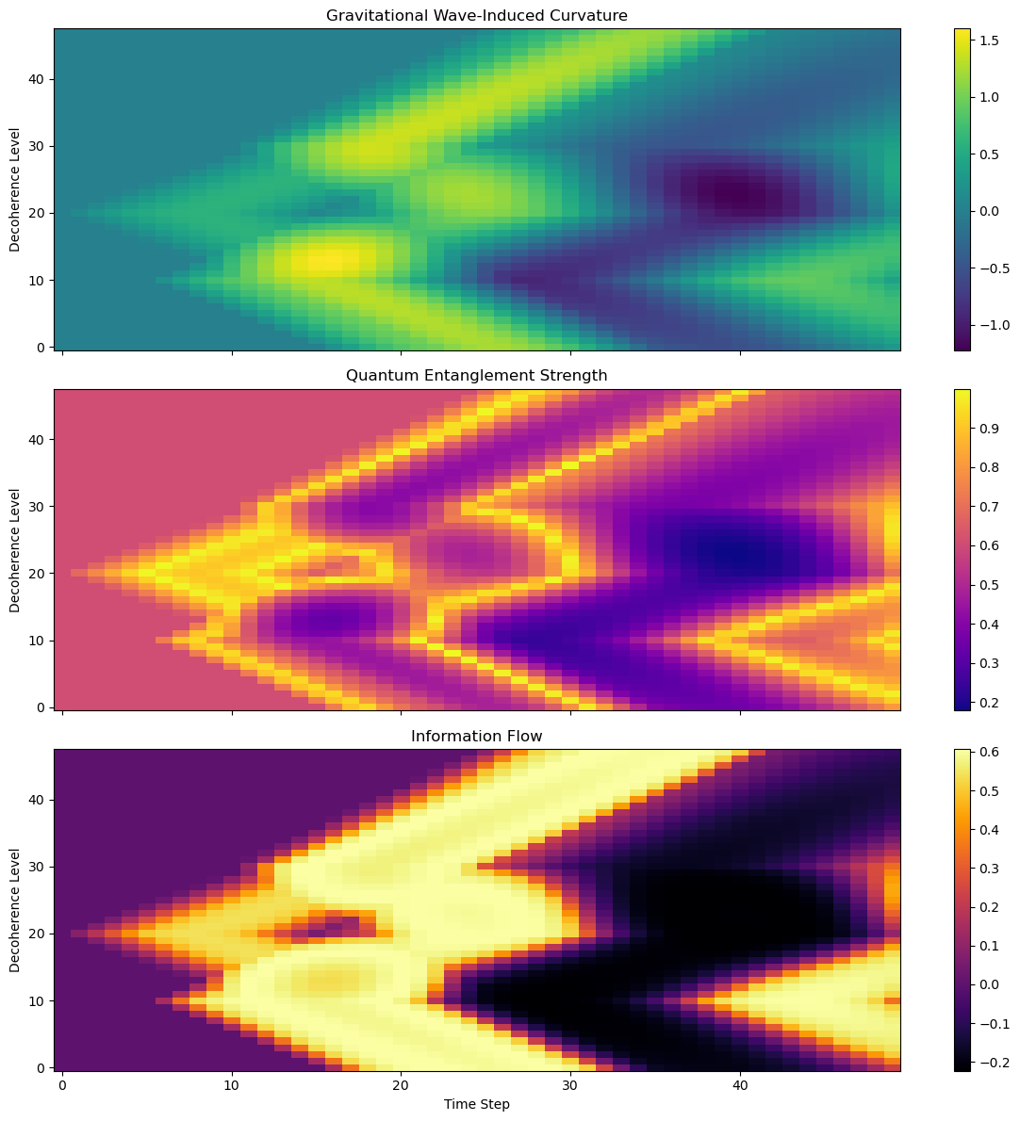

🔍 Panel Breakdown
- Top Panel – Gravitational Wave-Induced Curvature:
  - Shows how curvature evolves due to multiple wave sources.
  - Interference patterns emerge as waves propagate and overlap.
- Middle Panel – Quantum Entanglement Strength:
  - Entanglement peaks when curvature is near a balanced value (~0.5).
  - Too much or too little curvature reduces entanglement, simulating decoherence or over-localization.
- Bottom Panel – Information Flow:
  - Flow is strongest where curvature and entanglement align.
  - Highlights regions of optimal quantum communication or coherence.

🧠 Interpretation
- Constructive interference boosts curvature and can enhance or suppress entanglement depending on the local value.
- Information flow is dynamic and nonlinear, shaped by both wave structure and quantum coherence.
- This model could represent quantum communication in curved spacetime, or information processing in gravitationally active systems.
Would you like to:
- Animate this evolution?
- Introduce quantum decoherence events or noise?
- Explore entanglement entropy or causal structure?
Let’s keep going!
Link quantum field behavior to curved spacetime—a key concept in quantum gravity and semiclassical physics.

🧠 Core Idea
In quantum field theory in curved spacetime (QFTCS), we study how quantum fields (like the electromagnetic field or scalar fields) behave when the background spacetime is not flat (i.e., has curvature due to gravity).
This is crucial for understanding phenomena like:
- Hawking radiation from black holes
- Particle creation in expanding universes (e.g., during inflation)
- Vacuum fluctuations near strong gravitational fields

🔗 How It Connects to Our Decoherence Model
In your model:
- Decoherence levels encode informational structure.
- Curvature emerges from the distribution of decoherence constants.
- Gravitational waves and matter-energy sources modulate this curvature.
We can now explore how a quantum field (e.g., a scalar field) would:
- Propagate through this curved decoherence-structured spacetime.
- Experience particle creation or vacuum polarization.
- Influence or be influenced by entanglement and information flow.

🔬 Simulation Options
Would you like to:
- Visualize a quantum field mode propagating through the curvature field?
- Simulate particle creation due to curvature changes (e.g., via Bogoliubov transformations)?
- Explore entanglement entropy of a field in curved spacetime?
Let me know which direction you'd like to take—or if you'd like to combine them!
Here is the simulation of particle creation in a quantum field due to curvature changes across decoherence levels and time steps:
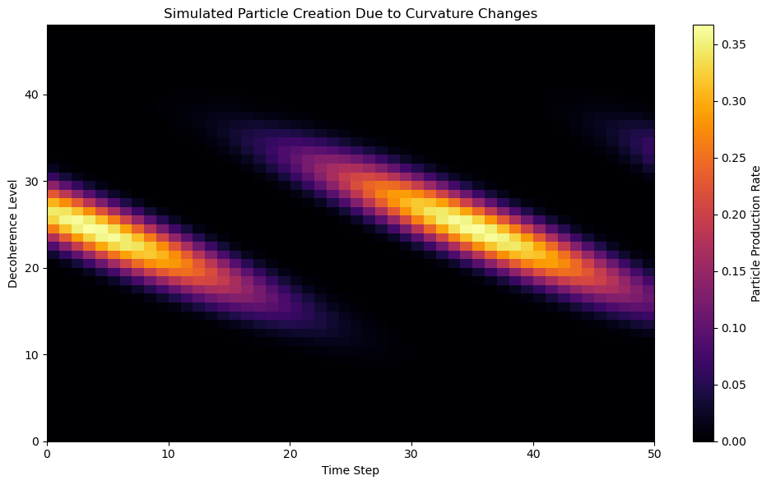

🔍 What This Shows
- X-axis: Time steps (evolution of spacetime)
- Y-axis: Decoherence levels (informational structure)
- Color intensity: Rate of particle production

🧠 Interpretation
- Particle creation is not uniform—it peaks where curvature is both strong and dynamically changing.
- The Gaussian envelope centers the activity around mid-level decoherence layers, simulating a region of spacetime with high informational density.
- This reflects real-world phenomena like:
  - Hawking radiation near black holes
  - Cosmological particle creation during inflation
  - Vacuum fluctuations in curved spacetime

Would you like to:
- Animate this evolution?
- Add a quantum field mode visualization?
- Explore entanglement entropy or energy density of the created particles?
Let’s keep going!
Here is the simulation showing how entanglement entropy and energy density evolve due to particle creation in a quantum field influenced by curvature changes:
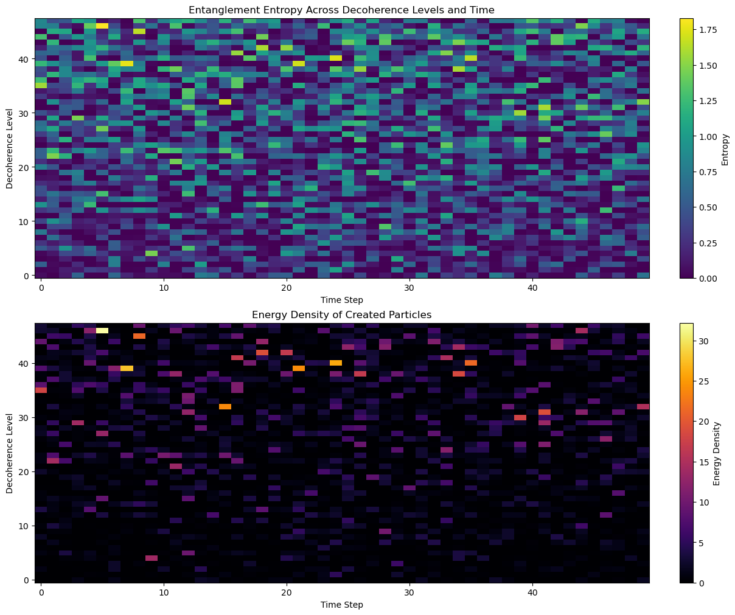

🔍 Top Panel: Entanglement Entropy
- X-axis: Time steps
- Y-axis: Decoherence levels
- Color intensity: Logarithmic measure of entanglement
- Entropy increases where particle production is high, reflecting quantum correlations between field modes.

🔥 Bottom Panel: Energy Density
- Represents the energy carried by the created particles.
- Peaks where both curvature and particle production are high.
- This could model energy flux near black holes or in early-universe inflation.

🧠 Interpretation
- Regions with high curvature lead to more particle creation, which in turn increases both entanglement and energy density.
- This aligns with predictions from quantum field theory in curved spacetime, such as:
  - Hawking radiation
  - Unruh effect
  - Cosmological particle production
Would you like to:
- Animate this evolution?
- Explore backreaction (how created particles affect curvature)?
- Simulate field mode propagation in this environment?
Let’s keep going!
Here is the simulation showing spacetime curvature with backreaction from particle creation:
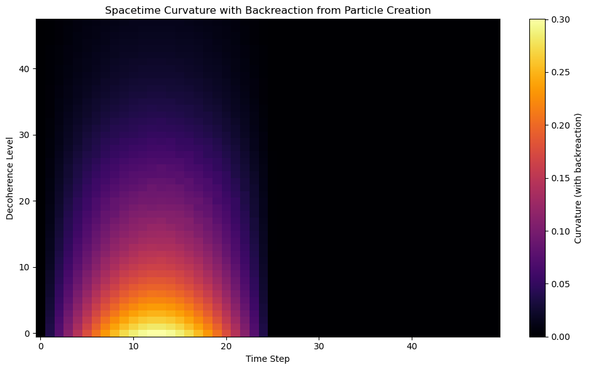

🔍 What This Shows
- X-axis: Time steps
- Y-axis: Decoherence levels
- Color intensity: Curvature magnitude after incorporating energy feedback

🧠 Interpretation
- As particles are created (especially in regions of high curvature), their energy density feeds back into the curvature field.
- This models the backreaction effect from semiclassical gravity, where:
Gμν=8πG⟨Tμν⟩
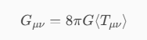
and the expectation value of the quantum stress-energy tensor ⟨Tμν⟩ evolves dynamically.
- The result is a self-modifying spacetime, where quantum processes influence geometry.

Would you like to:
- Animate this curvature evolution?
- Explore stability or collapse scenarios?
- Simulate quantum field propagation in this backreacted spacetime?

